Validation de l'IP d'acquisition GNSS
Analyse comparative CPU TSA LUT vs FPGA THESE vfin
Rapport genere automatiquement

1. Parametres de campagne
Parametre | Valeur
Frequence echantillonnage (fs) | 11.999 MHz
Frequence intermediaire (IF) | 3.563 MHz
Nombre echantillons (N) | 11999
Nombre phases code (nb_phases) | 1023
Plage Doppler | [-10000, 10000] Hz
Pas Doppler (fd_step) | 0 Hz
Nb frequences Doppler | 18
Seuil detection | Defini par l'algorithme
PRN injecte | [25]
PRN leurres par signal | 8
Nombre de fichiers signal | 86
Plage SNR | [-20.0, -10.0, 0.0, 10.0, 20.0]
Methodes comparees | CPU TSA LUT vs FPGA TSA

2. Resultats globaux par methode
Metriques agregees pour chaque methode sur l'ensemble de la campagne.
method | n_signaux | n_acquisitions | succes_strict_pct | Pd_pct | Pfa_pct | Pm_pct | doppler_mae_hz | doppler_max_hz | phase_mae_chip | phase_max_chip | peak_ratio_mean | peak_ratio_std | winner_margin_mean_db | winner_margin_min_db | time_mean_ms | time_median_ms | label
cpu_tsa_lut | 86 | 86 | 100.0000 | 100.0000 | 0.0000 | 0.0000 | 3.0233 | 250 | 0.0000 | 0 | 94.7611 | 33.4241 | 133.8234 | 17.1070 | 43626.1170 | 39777.7842 | CPU TSA LUT
fpga | 86 | 86 | 100.0000 | 100.0000 | 0.0000 | 0.0000 | 3.0233 | 250 | 0.0000 | 0 | 585.3834 | 321.4123 | 14.4721 | 2.6694 | 444.7101 | 437.7275 | FPGA TSA

3. Resultats par SNR
Ventilation des performances par niveau de rapport signal-sur-bruit.
method | snr_db | n | succes_strict_pct | Pd_pct | Pfa_pct | Pm_pct | doppler_mae_hz | phase_mae_chip | peak_ratio_mean | winner_margin_mean_db | time_mean_ms | label
cpu_tsa_lut | -20.0000 | 18 | 100.0000 | 100.0000 | 0.0000 | 0.0000 | 14.4444 | 0.0000 | 33.9968 | 135.2498 | 58412.4262 | CPU TSA LUT
fpga | -20.0000 | 18 | 100.0000 | 100.0000 | 0.0000 | 0.0000 | 14.4444 | 0.0000 | 34.0021 | 3.7039 | 470.3471 | FPGA TSA
cpu_tsa_lut | -10.0000 | 17 | 100.0000 | 100.0000 | 0.0000 | 0.0000 | 0.0000 | 0.0000 | 95.1144 | 132.5345 | 39593.5327 | CPU TSA LUT
fpga | -10.0000 | 17 | 100.0000 | 100.0000 | 0.0000 | 0.0000 | 0.0000 | 0.0000 | 450.0869 | 14.9618 | 439.3318 | FPGA TSA
cpu_tsa_lut | 0.0000 | 17 | 100.0000 | 100.0000 | 0.0000 | 0.0000 | 0.0000 | 0.0000 | 114.0627 | 140.5711 | 39739.2717 | CPU TSA LUT
fpga | 0.0000 | 17 | 100.0000 | 100.0000 | 0.0000 | 0.0000 | 0.0000 | 0.0000 | 792.3680 | 17.7278 | 437.5923 | FPGA TSA
cpu_tsa_lut | 10.0000 | 17 | 100.0000 | 100.0000 | 0.0000 | 0.0000 | 0.0000 | 0.0000 | 117.0264 | 126.8816 | 39923.1909 | CPU TSA LUT
fpga | 10.0000 | 17 | 100.0000 | 100.0000 | 0.0000 | 0.0000 | 0.0000 | 0.0000 | 839.7265 | 18.2823 | 437.5123 | FPGA TSA
cpu_tsa_lut | 20.0000 | 17 | 100.0000 | 100.0000 | 0.0000 | 0.0000 | 0.0000 | 0.0000 | 117.1794 | 133.7963 | 39592.3805 | CPU TSA LUT
fpga | 20.0000 | 17 | 100.0000 | 100.0000 | 0.0000 | 0.0000 | 0.0000 | 0.0000 | 843.1677 | 18.3183 | 437.2587 | FPGA TSA

3.1. Detection, fausse alarme et miss vs SNR
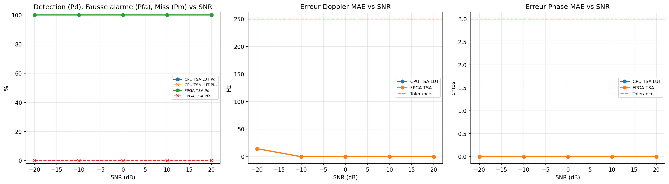

4. Analyse PFA sur PRN leurres

4.1. Volume injecte vs leurres
method | type | n
cpu_tsa_lut | PRN injecte | 86
cpu_tsa_lut | PRN leurre | 688
fpga | PRN injecte | 86
fpga | PRN leurre | 688

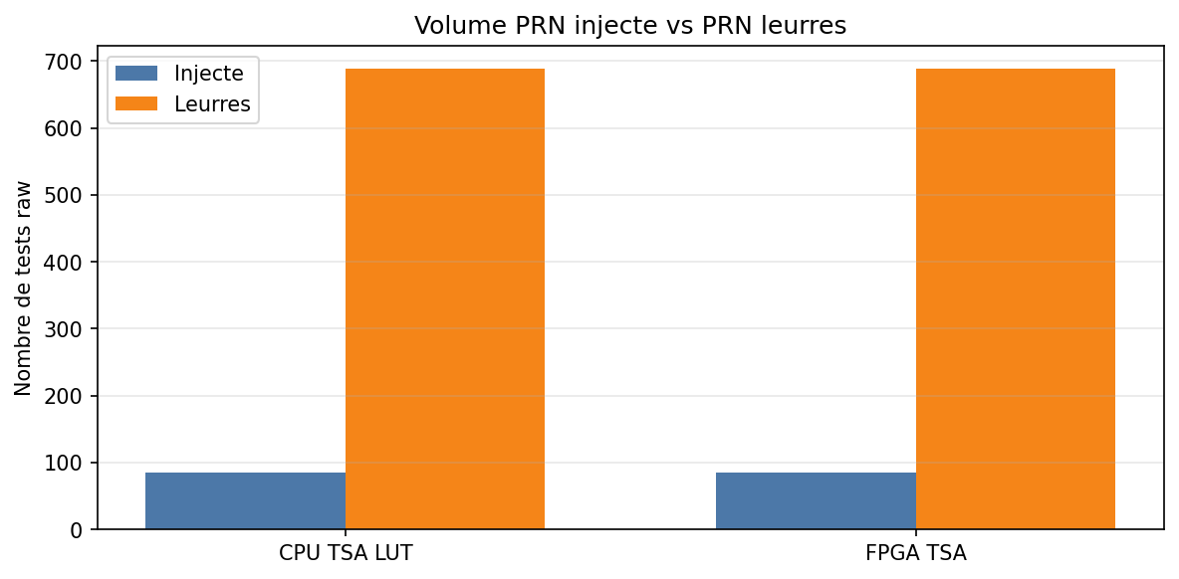

4.2. PFA globale
method | n_leurres | n_fausses_detections | Pfa_leurres_pct | peak_ratio_leurre_mean | peak_ratio_leurre_max | label
cpu_tsa_lut | 688 | 0 | 0.0000 | 0.0055 | 1.6984 | CPU TSA LUT
fpga | 688 | 688 | 100.0000 | 11.3590 | 16.3227 | FPGA TSA

4.3. PFA par SNR
method | snr_db | n_leurres | n_fausses_det | Pfa_pct | peak_ratio_max | label
cpu_tsa_lut | -20.0000 | 144 | 0 | 0.0000 | 0.0000 | CPU TSA LUT
fpga | -20.0000 | 144 | 144 | 100.0000 | 16.3227 | FPGA TSA
cpu_tsa_lut | -10.0000 | 136 | 0 | 0.0000 | 1.6984 | CPU TSA LUT
fpga | -10.0000 | 136 | 136 | 100.0000 | 15.8271 | FPGA TSA
cpu_tsa_lut | 0.0000 | 136 | 0 | 0.0000 | 0.0000 | CPU TSA LUT
fpga | 0.0000 | 136 | 136 | 100.0000 | 15.8037 | FPGA TSA
cpu_tsa_lut | 10.0000 | 136 | 0 | 0.0000 | 0.5510 | CPU TSA LUT
fpga | 10.0000 | 136 | 136 | 100.0000 | 15.0387 | FPGA TSA
cpu_tsa_lut | 20.0000 | 136 | 0 | 0.0000 | 0.5203 | CPU TSA LUT
fpga | 20.0000 | 136 | 136 | 100.0000 | 13.7138 | FPGA TSA

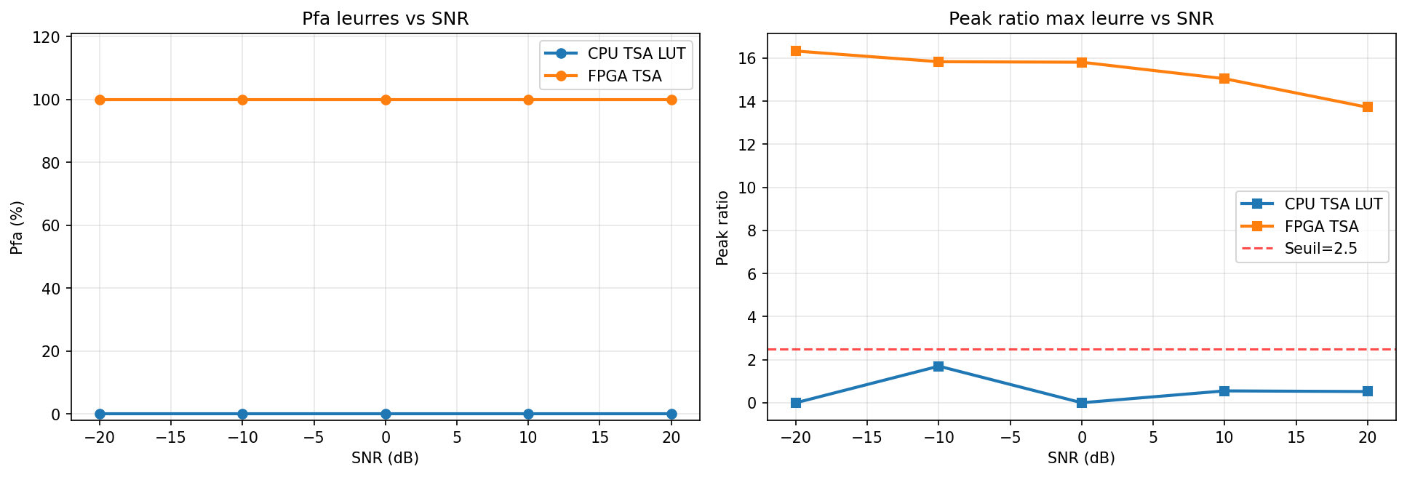

4.4. PFA par PRN leurre
method | prn_tested | n | n_false | Pfa_pct | peak_ratio_mean
cpu_tsa_lut | 1 | 16 | 0 | 0.0000 | 0.0000
cpu_tsa_lut | 2 | 27 | 0 | 0.0000 | 0.0000
cpu_tsa_lut | 3 | 20 | 0 | 0.0000 | 0.0260
cpu_tsa_lut | 4 | 17 | 0 | 0.0000 | 0.0000
cpu_tsa_lut | 5 | 21 | 0 | 0.0000 | 0.0000
cpu_tsa_lut | 6 | 16 | 0 | 0.0000 | 0.0311
cpu_tsa_lut | 7 | 27 | 0 | 0.0000 | 0.0000
cpu_tsa_lut | 8 | 20 | 0 | 0.0000 | 0.0000
cpu_tsa_lut | 9 | 19 | 0 | 0.0000 | 0.0000
cpu_tsa_lut | 10 | 20 | 0 | 0.0000 | 0.0000
cpu_tsa_lut | 11 | 23 | 0 | 0.0000 | 0.0000
cpu_tsa_lut | 12 | 17 | 0 | 0.0000 | 0.0000
cpu_tsa_lut | 13 | 25 | 0 | 0.0000 | 0.0000
cpu_tsa_lut | 14 | 17 | 0 | 0.0000 | 0.0000
cpu_tsa_lut | 15 | 30 | 0 | 0.0000 | 0.0000
cpu_tsa_lut | 16 | 28 | 0 | 0.0000 | 0.0000
cpu_tsa_lut | 17 | 18 | 0 | 0.0000 | 0.0000
cpu_tsa_lut | 18 | 18 | 0 | 0.0000 | 0.0000
cpu_tsa_lut | 19 | 27 | 0 | 0.0000 | 0.0195
cpu_tsa_lut | 20 | 29 | 0 | 0.0000 | 0.0000
cpu_tsa_lut | 21 | 18 | 0 | 0.0000 | 0.0306
cpu_tsa_lut | 22 | 24 | 0 | 0.0000 | 0.0000
cpu_tsa_lut | 23 | 27 | 0 | 0.0000 | 0.0000
cpu_tsa_lut | 24 | 25 | 0 | 0.0000 | 0.0000
cpu_tsa_lut | 26 | 20 | 0 | 0.0000 | 0.0000
cpu_tsa_lut | 27 | 17 | 0 | 0.0000 | 0.0000
cpu_tsa_lut | 28 | 24 | 0 | 0.0000 | 0.0708
cpu_tsa_lut | 29 | 19 | 0 | 0.0000 | 0.0000
cpu_tsa_lut | 30 | 27 | 0 | 0.0000 | 0.0000
cpu_tsa_lut | 31 | 26 | 0 | 0.0000 | 0.0000
cpu_tsa_lut | 32 | 26 | 0 | 0.0000 | 0.0000
fpga | 1 | 16 | 16 | 100.0000 | 11.3693
fpga | 2 | 27 | 27 | 100.0000 | 10.6403
fpga | 3 | 20 | 20 | 100.0000 | 11.3960
fpga | 4 | 17 | 17 | 100.0000 | 10.8626
fpga | 5 | 21 | 21 | 100.0000 | 11.3040
fpga | 6 | 16 | 16 | 100.0000 | 11.4075
fpga | 7 | 27 | 27 | 100.0000 | 12.4198
fpga | 8 | 20 | 20 | 100.0000 | 10.9857
fpga | 9 | 19 | 19 | 100.0000 | 10.3369
fpga | 10 | 20 | 20 | 100.0000 | 11.4765
fpga | 11 | 23 | 23 | 100.0000 | 11.5063
fpga | 12 | 17 | 17 | 100.0000 | 11.3344
fpga | 13 | 25 | 25 | 100.0000 | 11.6946
fpga | 14 | 17 | 17 | 100.0000 | 11.6076
fpga | 15 | 30 | 30 | 100.0000 | 11.2993
fpga | 16 | 28 | 28 | 100.0000 | 11.5273
fpga | 17 | 18 | 18 | 100.0000 | 10.6990
fpga | 18 | 18 | 18 | 100.0000 | 11.7976
fpga | 19 | 27 | 27 | 100.0000 | 10.9600
fpga | 20 | 29 | 29 | 100.0000 | 11.1092
fpga | 21 | 18 | 18 | 100.0000 | 11.2673
fpga | 22 | 24 | 24 | 100.0000 | 12.1382
fpga | 23 | 27 | 27 | 100.0000 | 12.2130
fpga | 24 | 25 | 25 | 100.0000 | 11.4923
fpga | 26 | 20 | 20 | 100.0000 | 11.1635
fpga | 27 | 17 | 17 | 100.0000 | 10.8857
fpga | 28 | 24 | 24 | 100.0000 | 11.3614
fpga | 29 | 19 | 19 | 100.0000 | 11.4804
fpga | 30 | 27 | 27 | 100.0000 | 11.7090
fpga | 31 | 26 | 26 | 100.0000 | 11.0968
fpga | 32 | 26 | 26 | 100.0000 | 10.9823

4.5. Peak Ratio injecte vs leurres
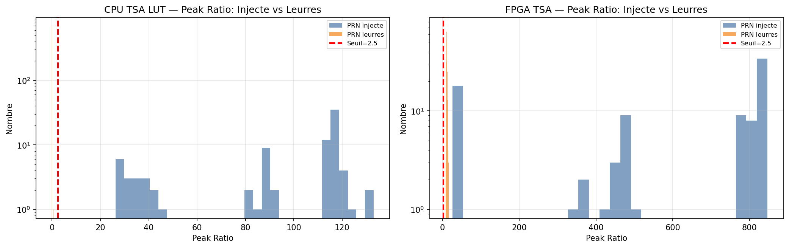

5. Concordance CPU TSA LUT vs FPGA THESE vfin

5.1. Concordance globale
gauche | droite | n_commun | accord_decision_pct | accord_prn_pct | accord_doppler_exact_pct | accord_phase_exact_pct | delta_doppler_moy_hz | delta_phase_moy_chip | delta_peak_ratio_moy | delta_peak_ratio_max | delta_margin_moy_db | correlation_peak_ratio
CPU TSA LUT | FPGA TSA | 86 | 100.0000 | 100.0000 | 100.0000 | 100.0000 | 0.0000 | 0.0000 | 490.6223 | 729.7665 | 119.3513 | 0.9352

5.2. Concordance par SNR
gauche | droite | snr_db | n | accord_decision_pct | accord_doppler_pct | accord_phase_pct | delta_peak_ratio_moy
CPU TSA LUT | FPGA TSA | -20.0000 | 18 | 100.0000 | 100.0000 | 100.0000 | 0.0053
CPU TSA LUT | FPGA TSA | -10.0000 | 17 | 100.0000 | 100.0000 | 100.0000 | 354.9725
CPU TSA LUT | FPGA TSA | 0.0000 | 17 | 100.0000 | 100.0000 | 100.0000 | 678.3053
CPU TSA LUT | FPGA TSA | 10.0000 | 17 | 100.0000 | 100.0000 | 100.0000 | 722.7001
CPU TSA LUT | FPGA TSA | 20.0000 | 17 | 100.0000 | 100.0000 | 100.0000 | 725.9883

5.3. Scatter CPU TSA LUT vs FPGA
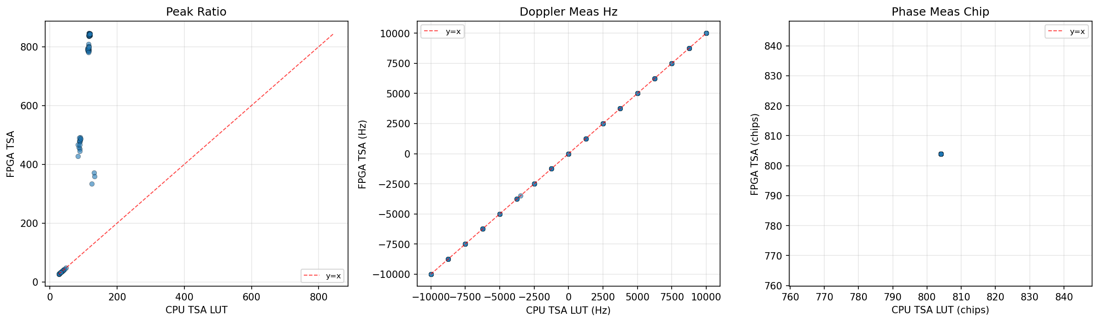

6. Graphiques detailles par methode

6.1. CPU TSA LUT
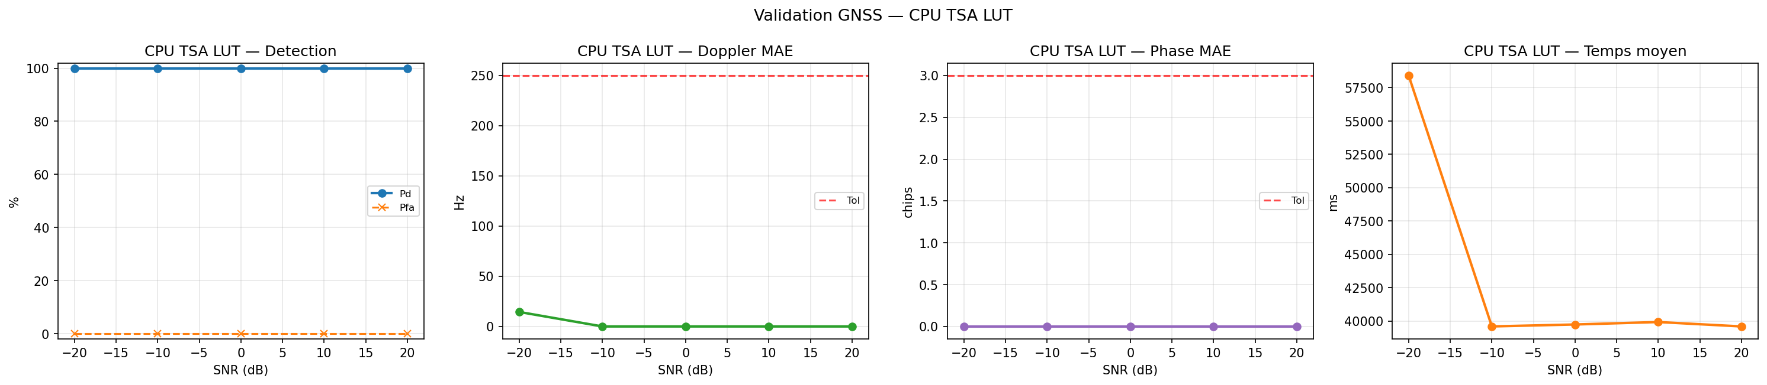
method | snr_db | n | succes_strict_pct | Pd_pct | Pfa_pct | Pm_pct | doppler_mae_hz | phase_mae_chip | peak_ratio_mean | winner_margin_mean_db | time_mean_ms | label
cpu_tsa_lut | -20.0000 | 18 | 100.0000 | 100.0000 | 0.0000 | 0.0000 | 14.4444 | 0.0000 | 33.9968 | 135.2498 | 58412.4262 | CPU TSA LUT
cpu_tsa_lut | -10.0000 | 17 | 100.0000 | 100.0000 | 0.0000 | 0.0000 | 0.0000 | 0.0000 | 95.1144 | 132.5345 | 39593.5327 | CPU TSA LUT
cpu_tsa_lut | 0.0000 | 17 | 100.0000 | 100.0000 | 0.0000 | 0.0000 | 0.0000 | 0.0000 | 114.0627 | 140.5711 | 39739.2717 | CPU TSA LUT
cpu_tsa_lut | 10.0000 | 17 | 100.0000 | 100.0000 | 0.0000 | 0.0000 | 0.0000 | 0.0000 | 117.0264 | 126.8816 | 39923.1909 | CPU TSA LUT
cpu_tsa_lut | 20.0000 | 17 | 100.0000 | 100.0000 | 0.0000 | 0.0000 | 0.0000 | 0.0000 | 117.1794 | 133.7963 | 39592.3805 | CPU TSA LUT

6.2. FPGA TSA
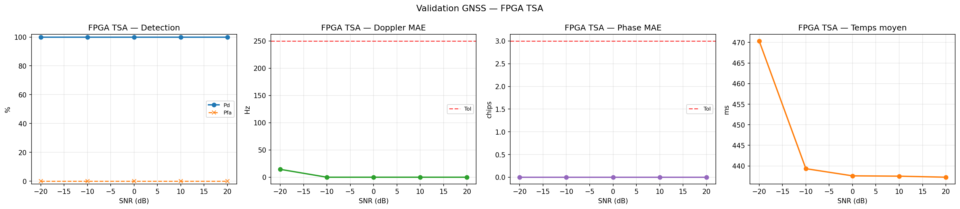
method | snr_db | n | succes_strict_pct | Pd_pct | Pfa_pct | Pm_pct | doppler_mae_hz | phase_mae_chip | peak_ratio_mean | winner_margin_mean_db | time_mean_ms | label
fpga | -20.0000 | 18 | 100.0000 | 100.0000 | 0.0000 | 0.0000 | 14.4444 | 0.0000 | 34.0021 | 3.7039 | 470.3471 | FPGA TSA
fpga | -10.0000 | 17 | 100.0000 | 100.0000 | 0.0000 | 0.0000 | 0.0000 | 0.0000 | 450.0869 | 14.9618 | 439.3318 | FPGA TSA
fpga | 0.0000 | 17 | 100.0000 | 100.0000 | 0.0000 | 0.0000 | 0.0000 | 0.0000 | 792.3680 | 17.7278 | 437.5923 | FPGA TSA
fpga | 10.0000 | 17 | 100.0000 | 100.0000 | 0.0000 | 0.0000 | 0.0000 | 0.0000 | 839.7265 | 18.2823 | 437.5123 | FPGA TSA
fpga | 20.0000 | 17 | 100.0000 | 100.0000 | 0.0000 | 0.0000 | 0.0000 | 0.0000 | 843.1677 | 18.3183 | 437.2587 | FPGA TSA

7. Heatmaps succes strict SNR x Doppler

7.1. CPU TSA LUT
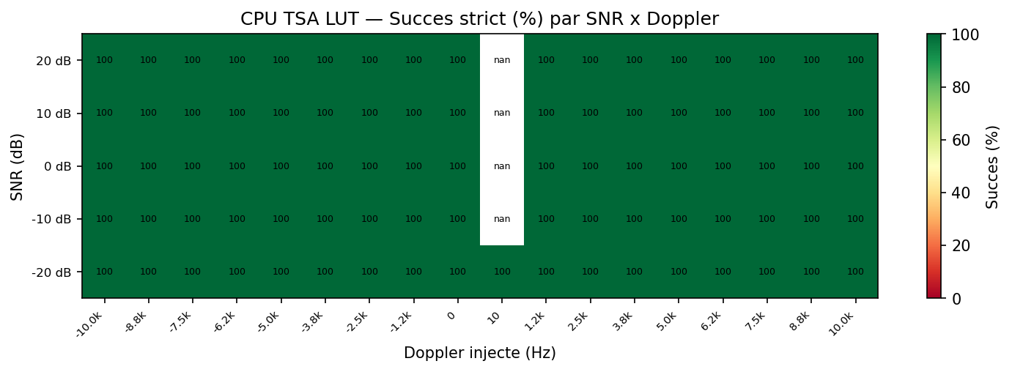
SNR (dB) | -10000 | -8750 | -7500 | -6250 | -5000 | -3750 | -2500 | -1250 | 0 | 10 | 1250 | 2500 | 3750 | 5000 | 6250 | 7500 | 8750 | 10000
-20.0000 | 100.0000 | 100.0000 | 100.0000 | 100.0000 | 100.0000 | 100.0000 | 100.0000 | 100.0000 | 100.0000 | 100.0000 | 100.0000 | 100.0000 | 100.0000 | 100.0000 | 100.0000 | 100.0000 | 100.0000 | 100.0000
-10.0000 | 100.0000 | 100.0000 | 100.0000 | 100.0000 | 100.0000 | 100.0000 | 100.0000 | 100.0000 | 100.0000 |  | 100.0000 | 100.0000 | 100.0000 | 100.0000 | 100.0000 | 100.0000 | 100.0000 | 100.0000
0.0000 | 100.0000 | 100.0000 | 100.0000 | 100.0000 | 100.0000 | 100.0000 | 100.0000 | 100.0000 | 100.0000 |  | 100.0000 | 100.0000 | 100.0000 | 100.0000 | 100.0000 | 100.0000 | 100.0000 | 100.0000
10.0000 | 100.0000 | 100.0000 | 100.0000 | 100.0000 | 100.0000 | 100.0000 | 100.0000 | 100.0000 | 100.0000 |  | 100.0000 | 100.0000 | 100.0000 | 100.0000 | 100.0000 | 100.0000 | 100.0000 | 100.0000
20.0000 | 100.0000 | 100.0000 | 100.0000 | 100.0000 | 100.0000 | 100.0000 | 100.0000 | 100.0000 | 100.0000 |  | 100.0000 | 100.0000 | 100.0000 | 100.0000 | 100.0000 | 100.0000 | 100.0000 | 100.0000

7.2. FPGA TSA
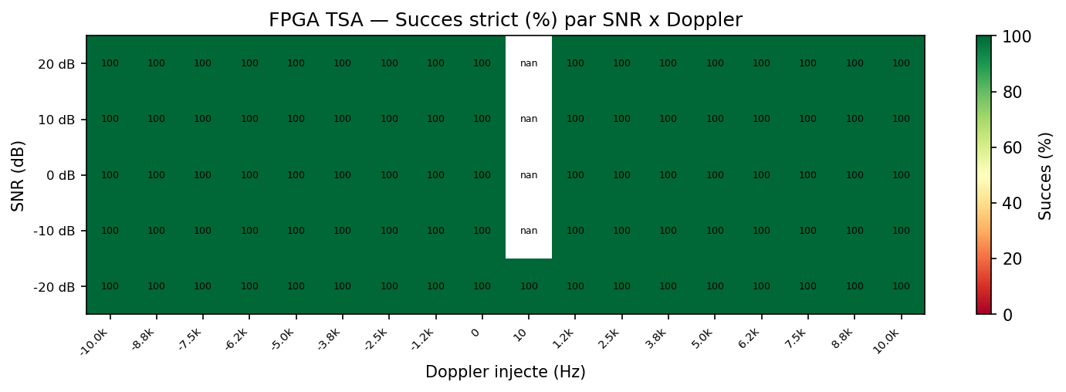
SNR (dB) | -10000 | -8750 | -7500 | -6250 | -5000 | -3750 | -2500 | -1250 | 0 | 10 | 1250 | 2500 | 3750 | 5000 | 6250 | 7500 | 8750 | 10000
-20.0000 | 100.0000 | 100.0000 | 100.0000 | 100.0000 | 100.0000 | 100.0000 | 100.0000 | 100.0000 | 100.0000 | 100.0000 | 100.0000 | 100.0000 | 100.0000 | 100.0000 | 100.0000 | 100.0000 | 100.0000 | 100.0000
-10.0000 | 100.0000 | 100.0000 | 100.0000 | 100.0000 | 100.0000 | 100.0000 | 100.0000 | 100.0000 | 100.0000 |  | 100.0000 | 100.0000 | 100.0000 | 100.0000 | 100.0000 | 100.0000 | 100.0000 | 100.0000
0.0000 | 100.0000 | 100.0000 | 100.0000 | 100.0000 | 100.0000 | 100.0000 | 100.0000 | 100.0000 | 100.0000 |  | 100.0000 | 100.0000 | 100.0000 | 100.0000 | 100.0000 | 100.0000 | 100.0000 | 100.0000
10.0000 | 100.0000 | 100.0000 | 100.0000 | 100.0000 | 100.0000 | 100.0000 | 100.0000 | 100.0000 | 100.0000 |  | 100.0000 | 100.0000 | 100.0000 | 100.0000 | 100.0000 | 100.0000 | 100.0000 | 100.0000
20.0000 | 100.0000 | 100.0000 | 100.0000 | 100.0000 | 100.0000 | 100.0000 | 100.0000 | 100.0000 | 100.0000 |  | 100.0000 | 100.0000 | 100.0000 | 100.0000 | 100.0000 | 100.0000 | 100.0000 | 100.0000

8. Distributions des erreurs
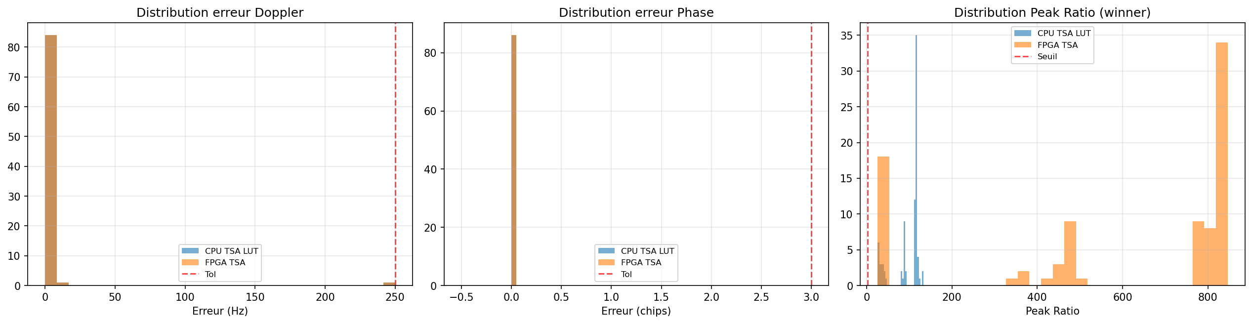

8.1. Statistiques erreurs par methode
method | doppler_err_mean | doppler_err_median | doppler_err_std | doppler_err_max | phase_err_mean | phase_err_median | phase_err_std | phase_err_max | peak_ratio_mean | peak_ratio_std | peak_ratio_min | peak_ratio_max | label
cpu_tsa_lut | 3.0233 | 0.0000 | 26.9671 | 250 | 0.0000 | 0.0000 | 0.0000 | 0 | 94.7611 | 33.4241 | 26.1927 | 132.9930 | CPU TSA LUT
fpga | 3.0233 | 0.0000 | 26.9671 | 250 | 0.0000 | 0.0000 | 0.0000 | 0 | 585.3834 | 321.4123 | 26.1949 | 846.0208 | FPGA TSA

9. Boxplots Peak Ratio et Winner Margin par SNR
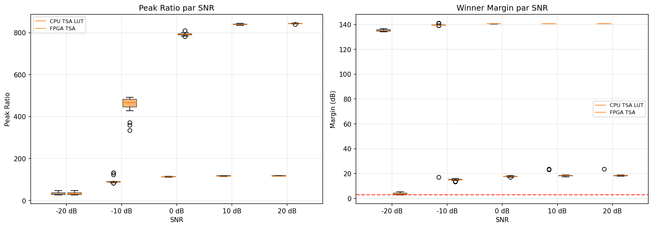
method | snr_db | peak_ratio_mean | peak_ratio_median | peak_ratio_min | peak_ratio_max | margin_mean_db | margin_min_db | margin_max_db
cpu_tsa_lut | -20.0000 | 33.9968 | 33.3652 | 26.1927 | 47.1247 | 135.2498 | 134.1818 | 136.7325
fpga | -20.0000 | 34.0021 | 33.3702 | 26.1949 | 47.1264 | 3.7039 | 2.6694 | 5.3868
cpu_tsa_lut | -10.0000 | 95.1144 | 88.2679 | 82.8028 | 132.9930 | 132.5345 | 17.1070 | 141.2383
fpga | -10.0000 | 450.0869 | 467.2278 | 334.3250 | 491.4544 | 14.9618 | 13.3981 | 15.8741
cpu_tsa_lut | 0.0000 | 114.0627 | 113.9555 | 111.7243 | 116.5128 | 140.5711 | 140.4815 | 140.6637
fpga | 0.0000 | 792.3680 | 791.2427 | 781.0063 | 809.1903 | 17.7278 | 17.0067 | 18.2862
cpu_tsa_lut | 10.0000 | 117.0264 | 116.0400 | 115.3025 | 118.8768 | 126.8816 | 23.2187 | 140.7510
fpga | 10.0000 | 839.7265 | 839.1317 | 835.4955 | 844.0580 | 18.2823 | 17.4640 | 18.9445
cpu_tsa_lut | 20.0000 | 117.1794 | 116.2543 | 115.4563 | 118.7733 | 133.7963 | 23.5844 | 140.7472
fpga | 20.0000 | 843.1677 | 843.0732 | 839.3048 | 846.0208 | 18.3183 | 17.8835 | 18.9111

10. Cas difficiles
Signaux tries par echec puis par marge de robustesse croissante. Ces cas representent les limites du systeme.
file | method | snr_db | prn_injected | prn_winner | pd_flag | pfa_flag | pm_flag | doppler_true_hz | doppler_meas_hz | doppler_err_hz | phase_true_chip | phase_meas_chip | phase_err_chip | peak_ratio | second_peak_ratio | winner_margin_db | strict_success
gps-1ms_prn-25_fs-11MHz_if-3563kHz_snr-n20_doppler-n10000Hz_ca-804.csv | fpga | -20.0000 | 25 | 25 | 1 | 0 | 0 | -10000 | -10000 | 0 | 804 | 804 | 0 | 26.1949 |  | 2.6694 | 1
gps-1ms_prn-25_fs-11MHz_if-3563kHz_snr-n20_doppler-n5000Hz_ca-804.csv | fpga | -20.0000 | 25 | 25 | 1 | 0 | 0 | -5000 | -5000 | 0 | 804 | 804 | 0 | 29.2432 |  | 2.6713 | 1
gps-1ms_prn-25_fs-11MHz_if-3563kHz_snr-n20_doppler-n3750Hz_ca-804.csv | fpga | -20.0000 | 25 | 25 | 1 | 0 | 0 | -3750 | -3500 | 250 | 804 | 804 | 0 | 27.1429 |  | 2.7337 | 1
gps-1ms_prn-25_fs-11MHz_if-3563kHz_snr-n20_doppler-p6250Hz_ca-804.csv | fpga | -20.0000 | 25 | 25 | 1 | 0 | 0 | 6250 | 6250 | 0 | 804 | 804 | 0 | 32.1356 |  | 2.9419 | 1
gps-1ms_prn-25_fs-11MHz_if-3563kHz_snr-n20_doppler-p7500Hz_ca-804.csv | fpga | -20.0000 | 25 | 25 | 1 | 0 | 0 | 7500 | 7500 | 0 | 804 | 804 | 0 | 31.5921 |  | 3.0398 | 1
gps-1ms_prn-25_fs-11MHz_if-3563kHz_snr-n20_doppler-n8750Hz_ca-804.csv | fpga | -20.0000 | 25 | 25 | 1 | 0 | 0 | -8750 | -8750 | 0 | 804 | 804 | 0 | 27.1385 |  | 3.3342 | 1
gps-1ms_prn-25_fs-11MHz_if-3563kHz_snr-n20_doppler-n7500Hz_ca-804.csv | fpga | -20.0000 | 25 | 25 | 1 | 0 | 0 | -7500 | -7500 | 0 | 804 | 804 | 0 | 28.7450 |  | 3.3607 | 1
gps-1ms_prn-25_fs-11MHz_if-3563kHz_snr-n20_doppler-p8750Hz_ca-804.csv | fpga | -20.0000 | 25 | 25 | 1 | 0 | 0 | 8750 | 8750 | 0 | 804 | 804 | 0 | 32.8233 |  | 3.5057 | 1
gps-1ms_prn-25_fs-11MHz_if-3563kHz_snr-n20_doppler-n6250Hz_ca-804.csv | fpga | -20.0000 | 25 | 25 | 1 | 0 | 0 | -6250 | -6250 | 0 | 804 | 804 | 0 | 26.5909 |  | 3.5111 | 1
gps-1ms_prn-25_fs-11MHz_if-3563kHz_snr-n20_doppler-p0Hz_ca-804.csv | fpga | -20.0000 | 25 | 25 | 1 | 0 | 0 | 0 | 0 | 0 | 804 | 804 | 0 | 35.0705 |  | 3.5905 | 1
gps-1ms_prn-25_fs-11MHz_if-3563kHz_snr-n20_doppler-p3750Hz_ca-804.csv | fpga | -20.0000 | 25 | 25 | 1 | 0 | 0 | 3750 | 3750 | 0 | 804 | 804 | 0 | 35.4166 |  | 3.9265 | 1
gps-1ms_prn-25_fs-11MHz_if-3563kHz_snr-n20_doppler-p1250Hz_ca-804.csv | fpga | -20.0000 | 25 | 25 | 1 | 0 | 0 | 1250 | 1250 | 0 | 804 | 804 | 0 | 33.9172 |  | 4.1568 | 1
gps-1ms_prn-25_fs-11MHz_if-3563kHz_snr-n20_doppler-p10000Hz_ca-804.csv | fpga | -20.0000 | 25 | 25 | 1 | 0 | 0 | 10000 | 10000 | 0 | 804 | 804 | 0 | 40.0486 |  | 4.3010 | 1
gps-1ms_prn-25_fs-11MHz_if-3563kHz_snr-n20_doppler-n2500Hz_ca-804.csv | fpga | -20.0000 | 25 | 25 | 1 | 0 | 0 | -2500 | -2500 | 0 | 804 | 804 | 0 | 37.2034 |  | 4.3160 | 1
gps-1ms_prn-25_fs-11MHz_if-3563kHz_snr-n20_doppler-p2500Hz_ca-804.csv | fpga | -20.0000 | 25 | 25 | 1 | 0 | 0 | 2500 | 2500 | 0 | 804 | 804 | 0 | 42.8407 |  | 4.3390 | 1
gps-1ms_prn-25_fs-11MHz_if-3563kHz_snr-n20_doppler-p5000Hz_ca-804.csv | fpga | -20.0000 | 25 | 25 | 1 | 0 | 0 | 5000 | 5000 | 0 | 804 | 804 | 0 | 37.8573 |  | 4.3423 | 1
gps-1ms_prn-25_fs-11MHz_if-3563kHz_snr-n20_doppler-n1250Hz_ca-804.csv | fpga | -20.0000 | 25 | 25 | 1 | 0 | 0 | -1250 | -1250 | 0 | 804 | 804 | 0 | 40.9514 |  | 4.5435 | 1
gps-1ms_prn-25_fs-11MHz_if-3563kHz_snr-n20_doppler-p10Hz_ca-804.csv | fpga | -20.0000 | 25 | 25 | 1 | 0 | 0 | 10 | 0 | 10 | 804 | 804 | 0 | 47.1264 |  | 5.3868 | 1
gps-1ms_prn-25_fs-11MHz_if-3563kHz_snr-n10_doppler-p6250Hz_ca-804.csv | fpga | -10.0000 | 25 | 25 | 1 | 0 | 0 | 6250 | 6250 | 0 | 804 | 804 | 0 | 334.3250 |  | 13.3981 | 1
gps-1ms_prn-25_fs-11MHz_if-3563kHz_snr-n10_doppler-p1250Hz_ca-804.csv | fpga | -10.0000 | 25 | 25 | 1 | 0 | 0 | 1250 | 1250 | 0 | 804 | 804 | 0 | 359.3571 |  | 13.8740 | 1

11. Analyse de performance

11.1. Comparaison des temps
method | n | time_mean_ms | time_median_ms | time_p95_ms | time_p99_ms | e2e_mean_ms | speedup_vs_cpu | label
cpu_tsa_lut | 86 | 43626.1170 | 39777.7842 | 59687.9975 | 62168.9820 |  | 1.0000 | CPU TSA LUT
fpga | 86 | 444.7101 | 437.7275 | 470.7910 | 471.2553 |  | 98.1001 | FPGA TSA

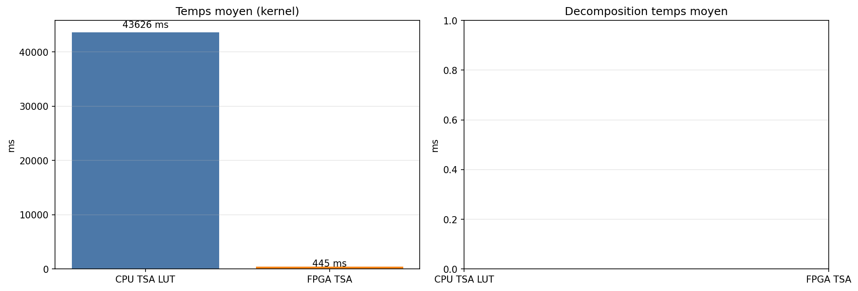

11.2. Profiling detaille
message
Aucune colonne de timing detaille exploitable dans winner_results.csv

12. Domaine de validite
Resume du domaine dans lequel chaque methode produit un resultat strictement correct (PRN, Doppler et phase dans les tolerances).
method | label | snr_min_ok_db | snr_max_ok_db | doppler_min_ok_hz | doppler_max_ok_hz | n_succes | n_total | taux_succes_pct | doppler_max_err_hz | phase_max_err_chip
cpu_tsa_lut | CPU TSA LUT | -20.0000 | 20.0000 | -10000 | 10000 | 86 | 86 | 100.0000 | 250 | 0
fpga | FPGA TSA | -20.0000 | 20.0000 | -10000 | 10000 | 86 | 86 | 100.0000 | 250 | 0

13. Resume final
Fichiers signal analyses: 86
SNR testes: [-20.0, -10.0, 0.0, 10.0, 20.0] dB
Plage Doppler: [-10000, 10000] Hz
PRN injecte: [25]
PRN leurres/signal: 8

--- CPU TSA LUT (86 acquisitions) ---
Succes strict: 100.00%
Pd: 100.00% | Pfa: 0.00% | Pm: 0.00%
Doppler MAE: 3.02 Hz
Phase MAE: 0.00 chips
Temps kernel: 43626.1 ms

--- FPGA TSA (86 acquisitions) ---
Succes strict: 100.00%
Pd: 100.00% | Pfa: 0.00% | Pm: 0.00%
Doppler MAE: 3.02 Hz
Phase MAE: 0.00 chips
Temps kernel: 444.7 ms

--- CPU TSA LUT PFA leurres (688 tests) ---
Fausses detections: 0
Pfa: 0.00%

--- FPGA TSA PFA leurres (688 tests) ---
Fausses detections: 688
Pfa: 100.00%

--- Concordance CPU TSA LUT vs FPGA TSA ---
Accord decision: 100.00%
Accord PRN: 100.00%
Accord Doppler exact: 100.00%
Correlation peak ratio: 0.935249

Speedup FPGA vs CPU: 98.1x

